**SOLUTIONS:**

1. **Display the list of cases with the same age.**

SQL>

Select distinct c.Case_Stage , c.Owning_User , c.Age

From Cases c, Cases c1

where c.Age = c1.Age

and c.caseid != c1.caseid ;

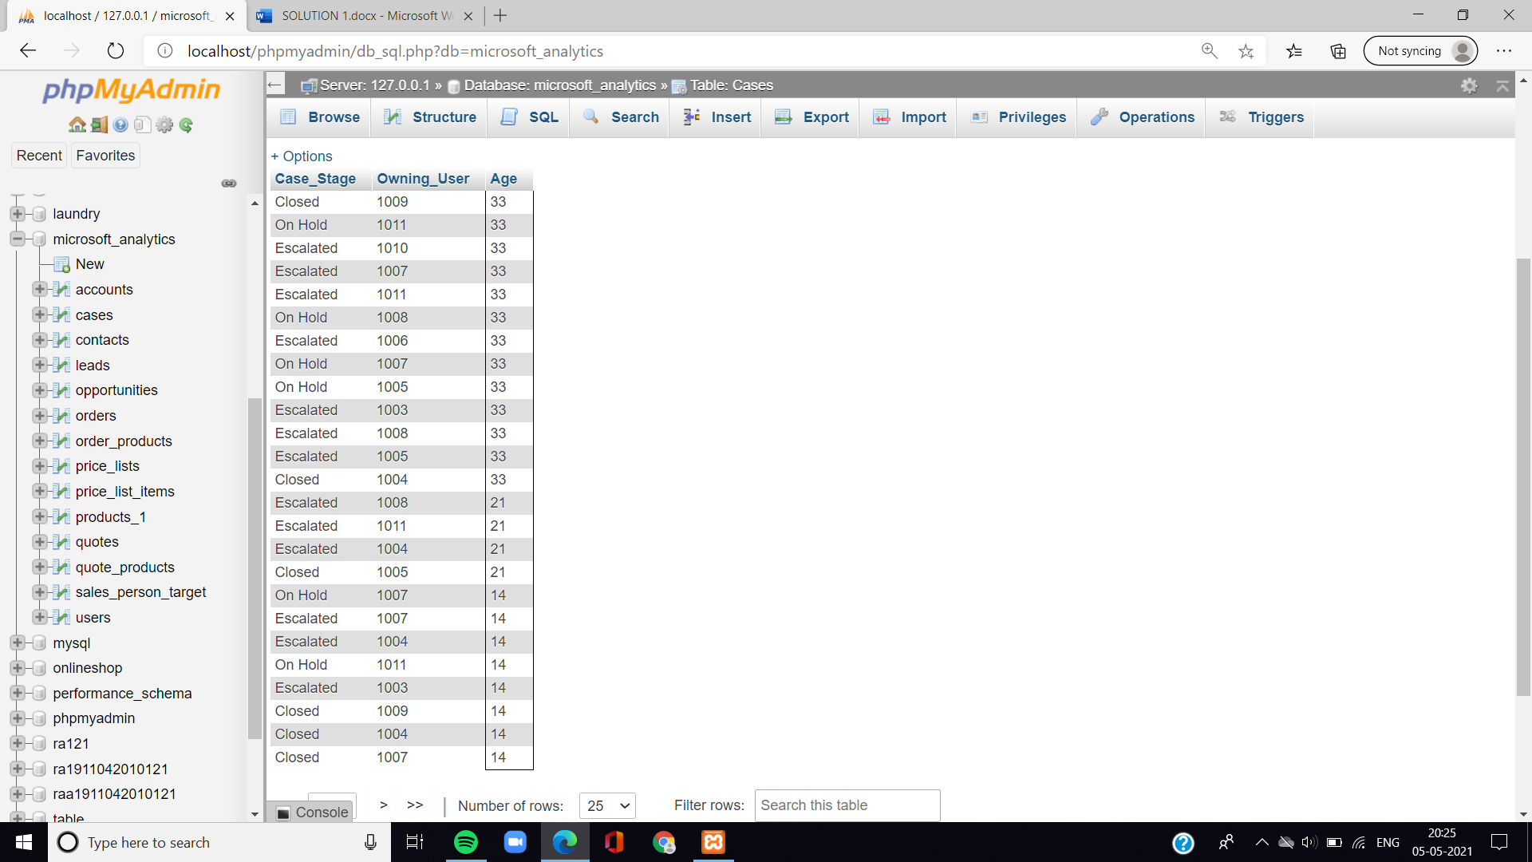

1. **Find the no. Of accounts for each industry in the descending order.**

SQL>

Select industry , count(account) no_of_accounts

From accounts

Group by industry

Order by no_of_accounts DESC;

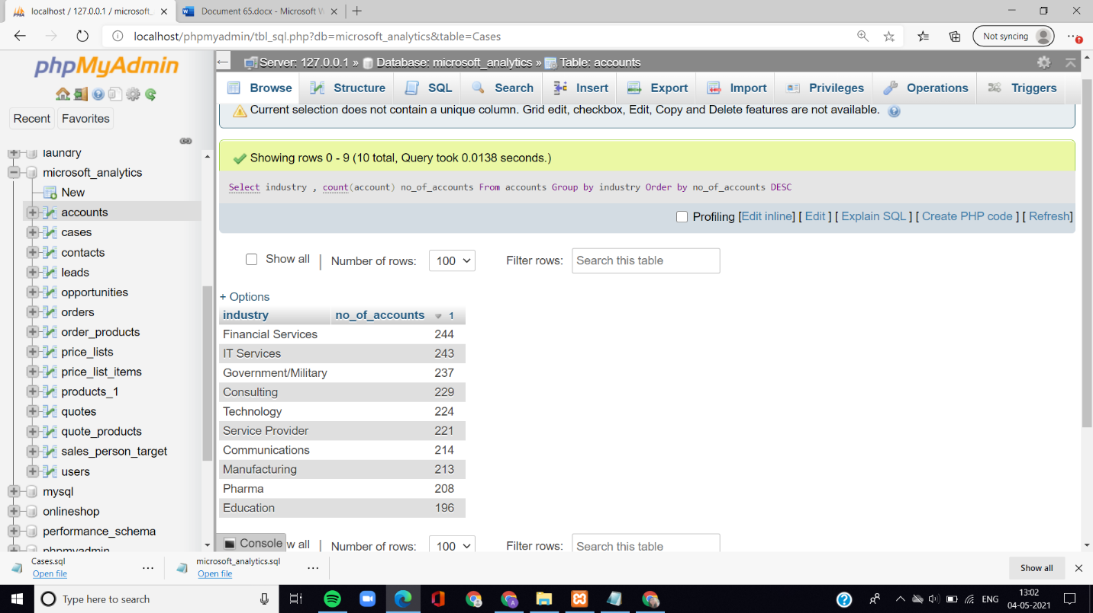

1. **Find the 3rd maximum current cost in products table.**

SQL>

Select distinct current_cost from products_1 p1

where 3 =

(select count(distinct current_cost )

from products_1 p2

where p1.current_cost <= p2.current_cost);

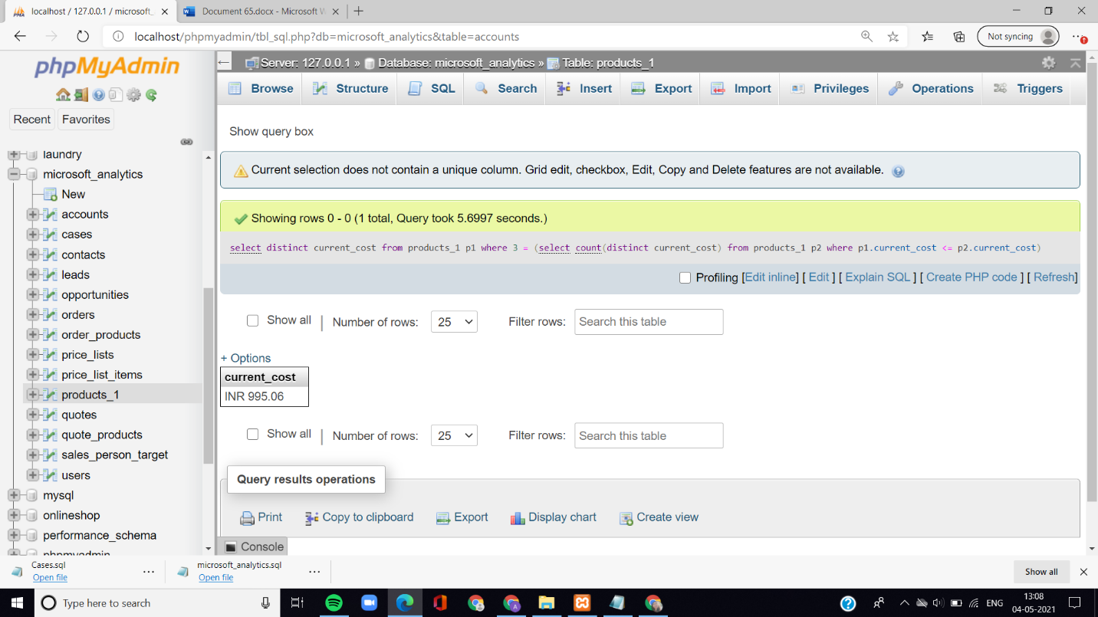

1. **Write a query to fetch 200 maximum Current cost from products table.**

SQL>

select distinct current_cost from products_1 p1

where 200 >=

(select count(distinct current_cost)

from products_1 p2

where p1.current_cost <= p2.current_cost)

ORDER BY p1.Current_Cost DESC;

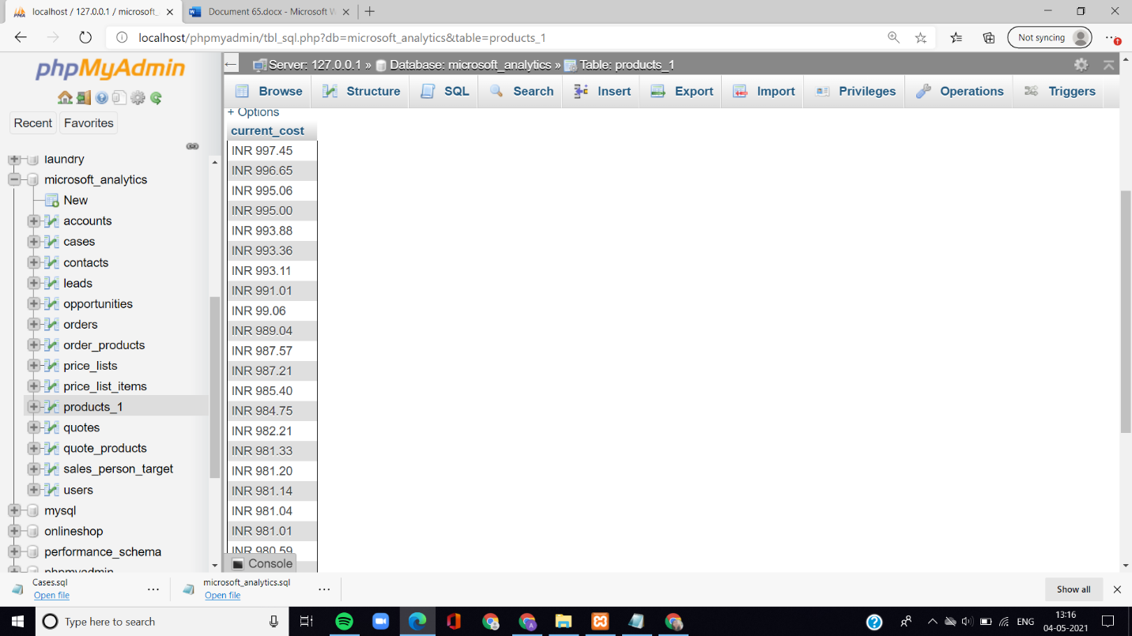

1. **Display the accounts name, industry, caseid to cases in every account.**

SQL>

Select accounts.Account_Name ,accounts.Industry , cases.caseid

from accounts

join cases on accounts.Owning_User = cases.Owning_User;

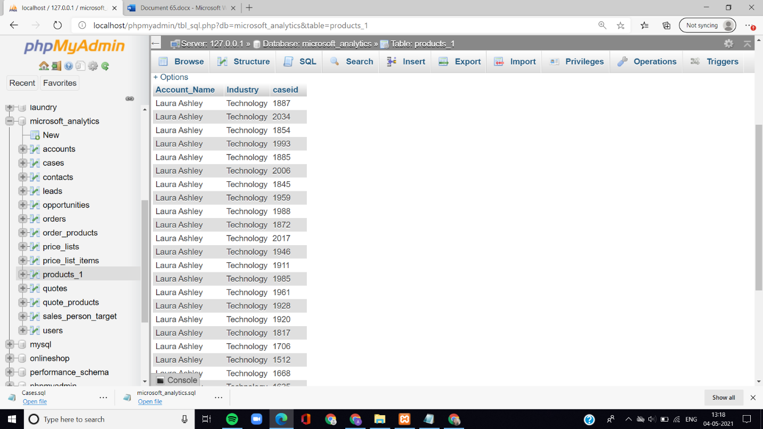

1. **Display the owning user, account id, status reason, amount and quantity of products to every orders.**

SQL>

Select orders.Owning_User, orders.Account_ID, orders.Status_Reason, order_products.Amount, order_products.quantity

from orders

join order_products on

orders.Orders_id =order_products.Orders_id;

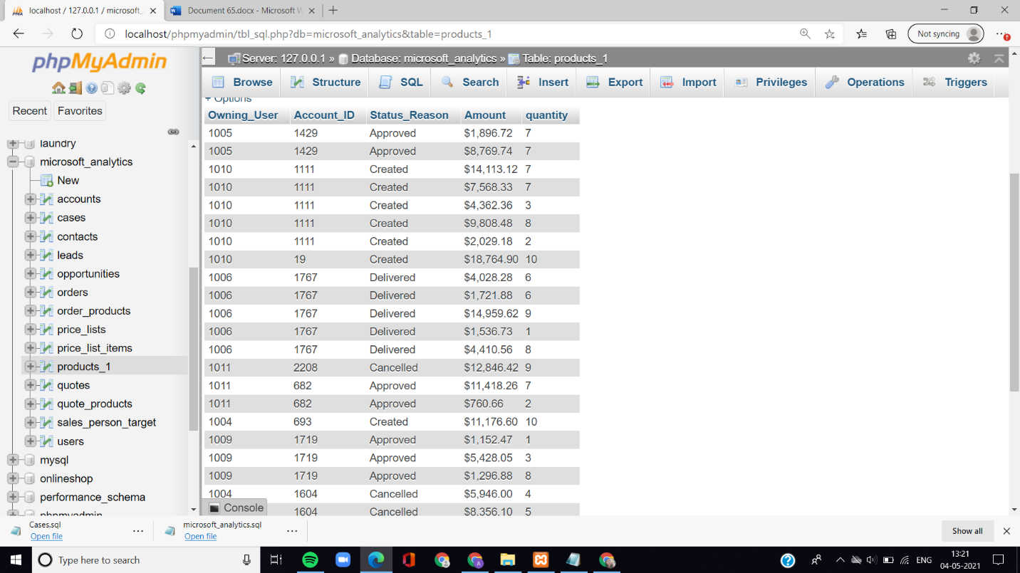

1. **Select all records where full name of both sales_person_target and users table matches.**

SQL>

SELECT * FROM sales_person_target

WHERE EXISTS( SELECT * FROM users

WHERE sales_person_target.Full_Name= users.Full_Name);

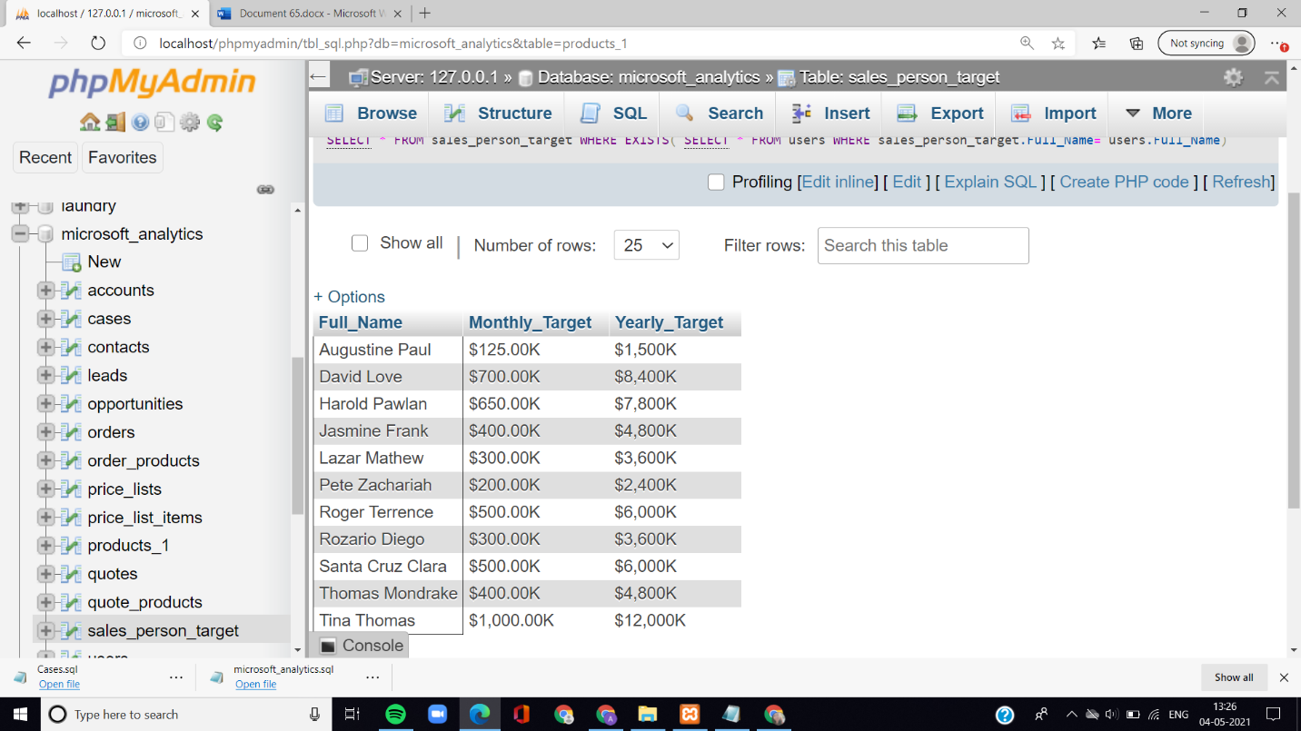

1. **Count the number of quote products in quote wise and also display the name.**

SQL>

SELECT COUNT(Quote_Product),b.quote,Name

FROM quote_products a, quotes b

WHERE a.Quote=b.Quote

GROUP BY b.Quote, Name;

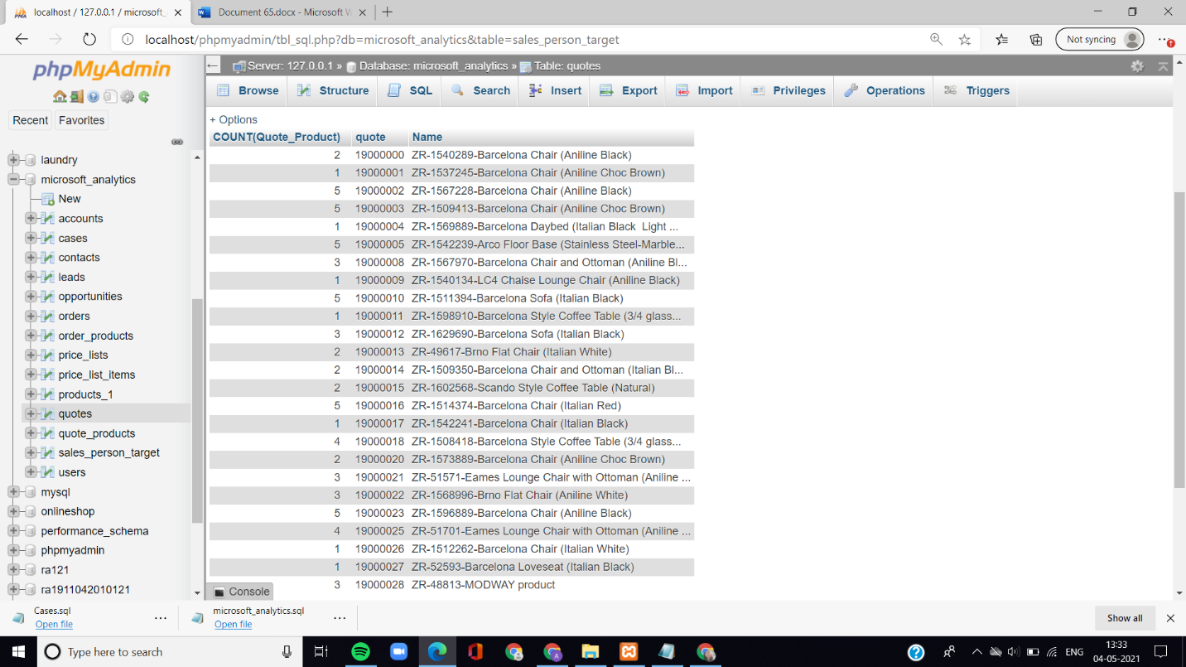

1. **Write a query to find the names of quotes which has highest total amount and also display the quote id.**

**SQL>**

Select name , quote, quote_id ,total_amount

from quotes

where total_amount =

(select max (total_amount)

from quotes);

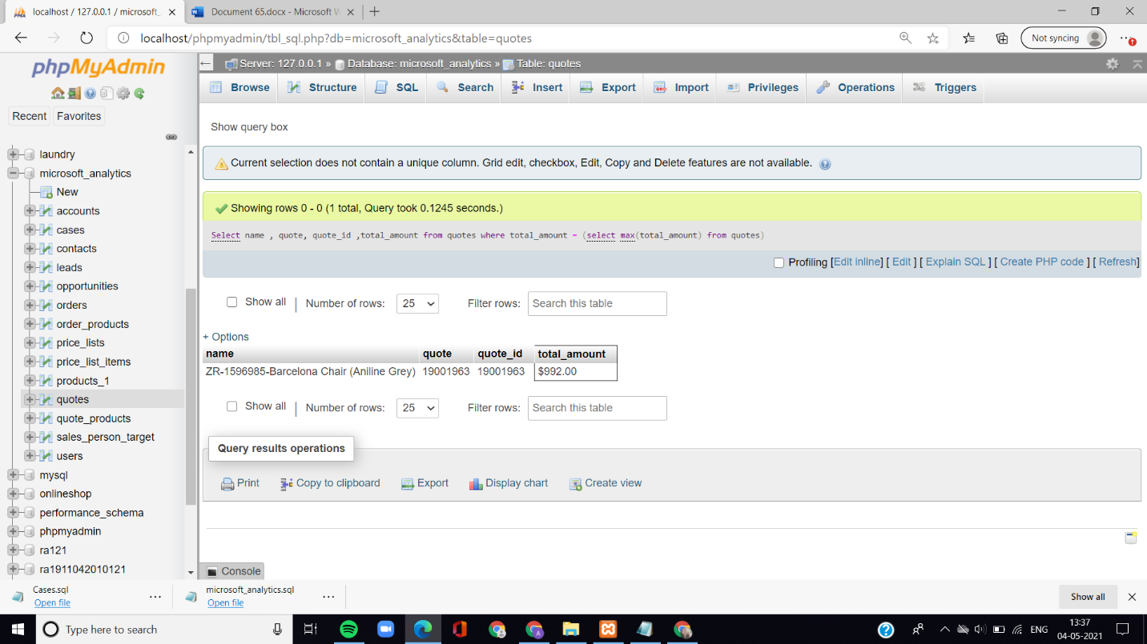

1. **Write a query to fetch 100 minimum Total Amount from quotes table.**

**SQL>**

Select distinct total_amount

from quotes a

Where 100 >= (select count(distinct total_amount)

from quotes b

where a.total_amount >= b.total_amount) order by a.total_amount ASC;

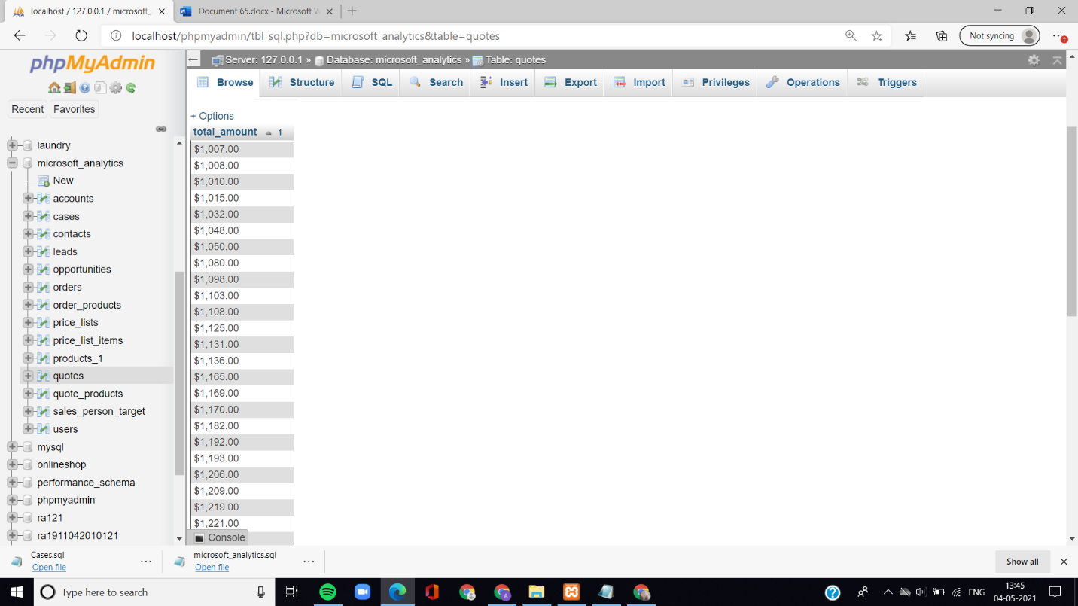

1. **Write an SQL query to print the name of product having the highest total amount in each product type.**

**SQL>**

SELECT p.Product_Type, p.Name, p.Current_Cost

FROM (SELECT MAX(Current_Cost) AS Total_Current_cost, Product_type

FROM products_1 GROUP BY product_type) AS Pro_New

INNER JOIN products_1 p

ON Pro_New.Product_type = p.Product_type

AND Pro_New.Total_Current_cost = p.Current_Cost;

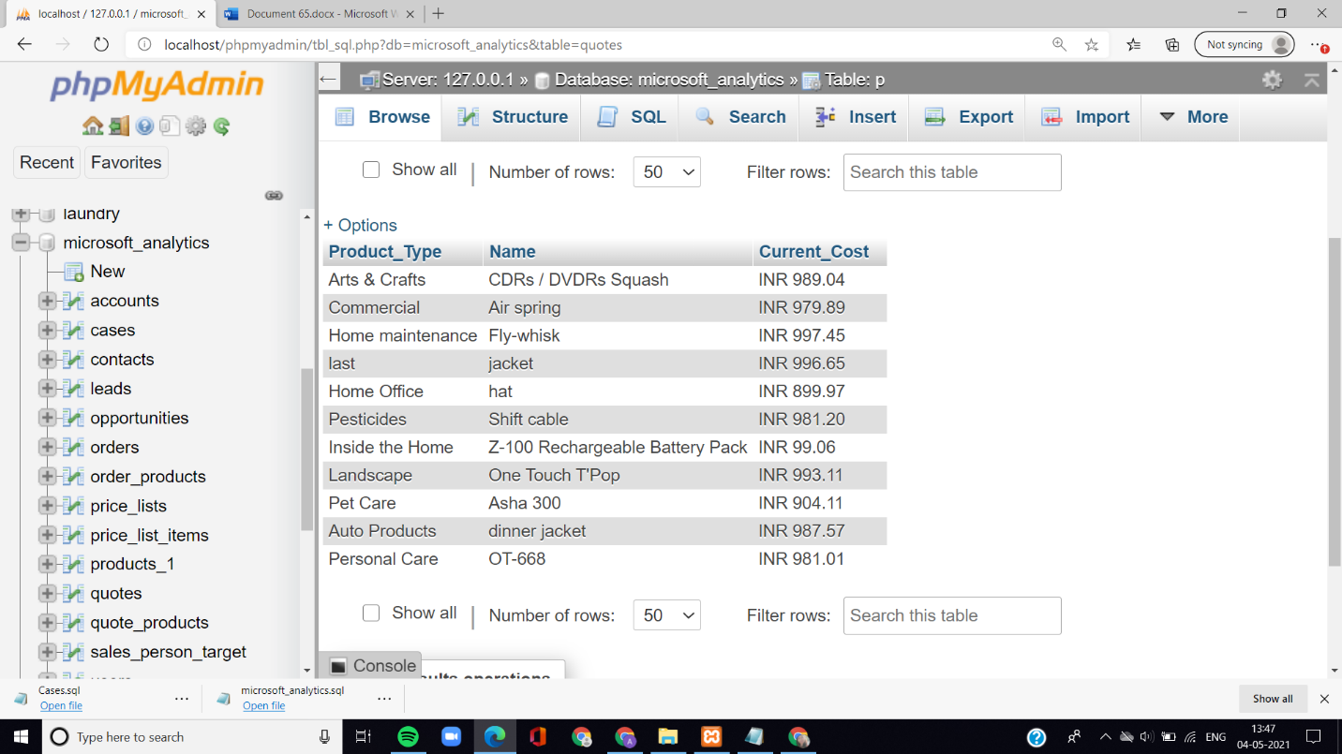

1. **Write an SQL query to fetch the last 20 records from accounts table using union.**

**SQL>**

SELECT * FROM accounts

WHERE Account <=20

UNION

SELECT * FROM(

SELECT * FROM accounts a

ORDER BY a.Account DESC)

AS a1 WHERE a1.account <=20;

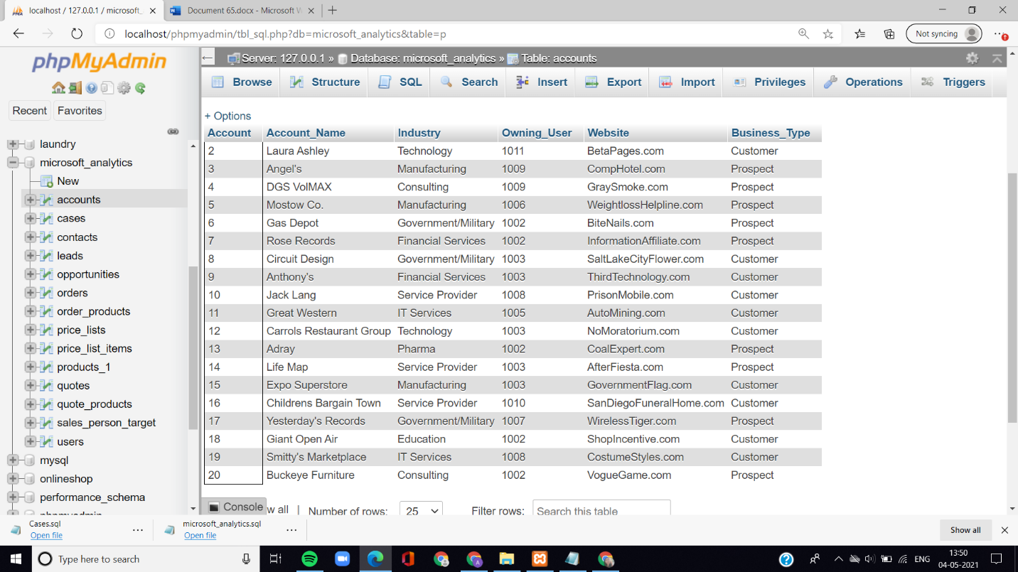

1. **Write an SQL query to show the row where industry is manufacturing twice in results**.

SQL>

Select account_name, industry, owning_user, business_type

from accounts a

where a.industry = 'manufacturing'

Union all

select account_name, industry, owning_user, business_type

from accounts a1

where a1.industry = 'manufacturing';

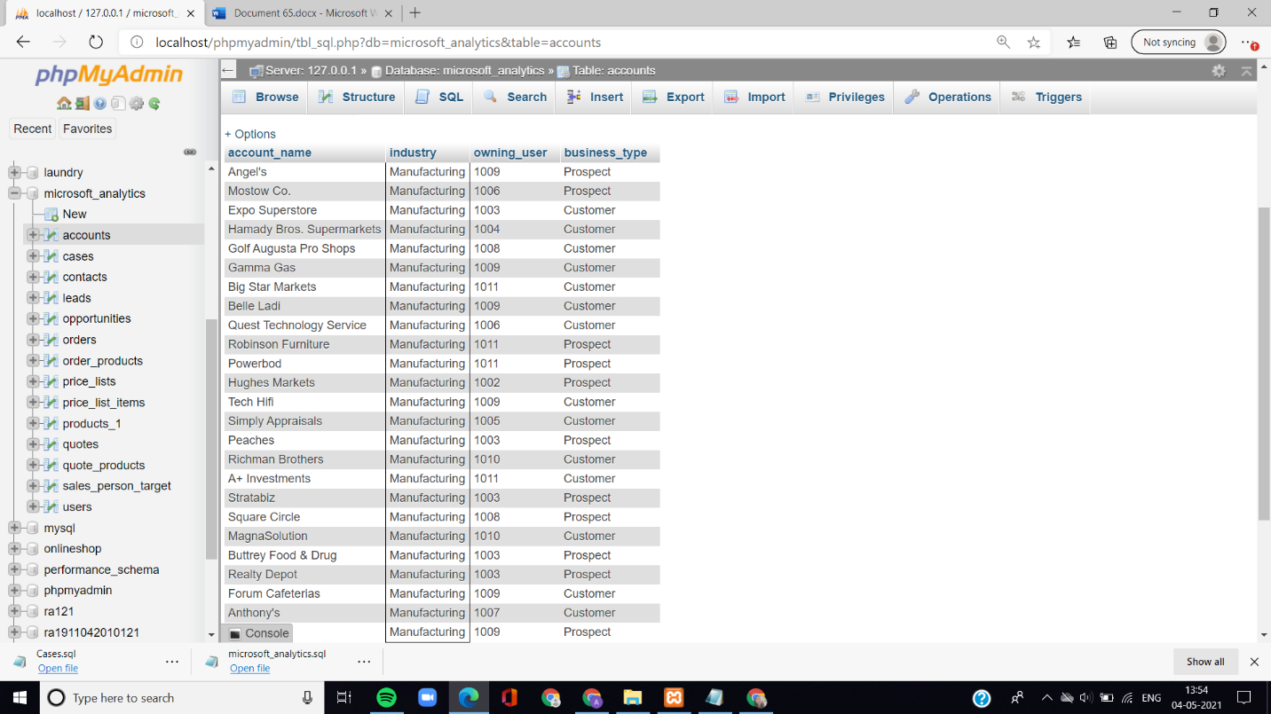

1. **Write an SQL query to fetch the list of account name with the same industry and also display their account, owning user, website and business type.**

**SQL>**

SELECT DISTINCT a.account, a.account_name, a.Owning_User,

a.Industry, a.website, a.Business_Type

FROM accounts a, accounts a1

WHERE a.Industry = a1.Industry

AND a.Account != a1.Account;

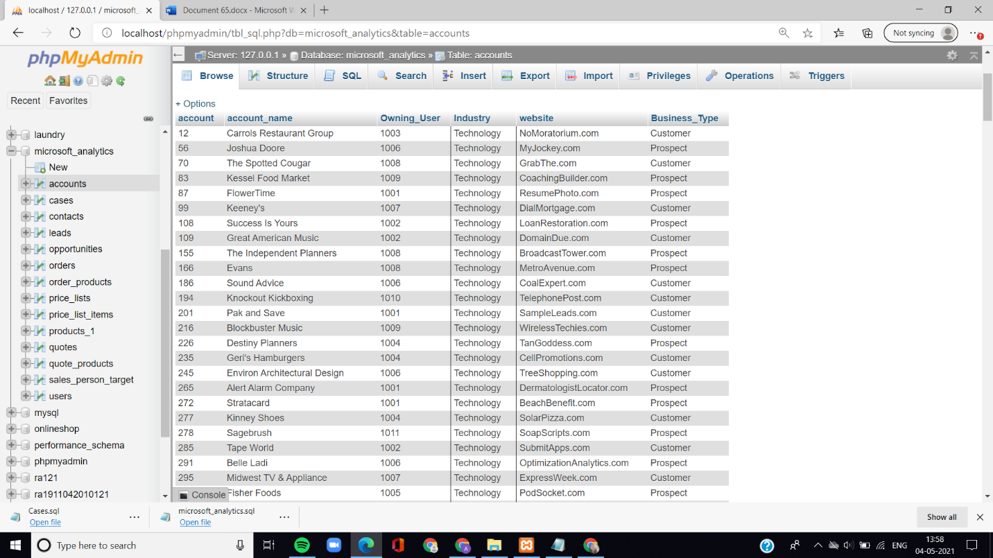

1. **Write a query to fetch the list of caseid, created_on, case_stage, age, age_tier who have their cases in industry manufacturing or pharma.**

**SQL>**

Select caseid, Origin, Created_On, Case_Stage, Age, Age_tier

from cases

where owning_user in (select owning_user

from contacts

where lead_source in

(select lead_source

from leads

where industry = 'manufacturing' or industry = 'Pharma'));

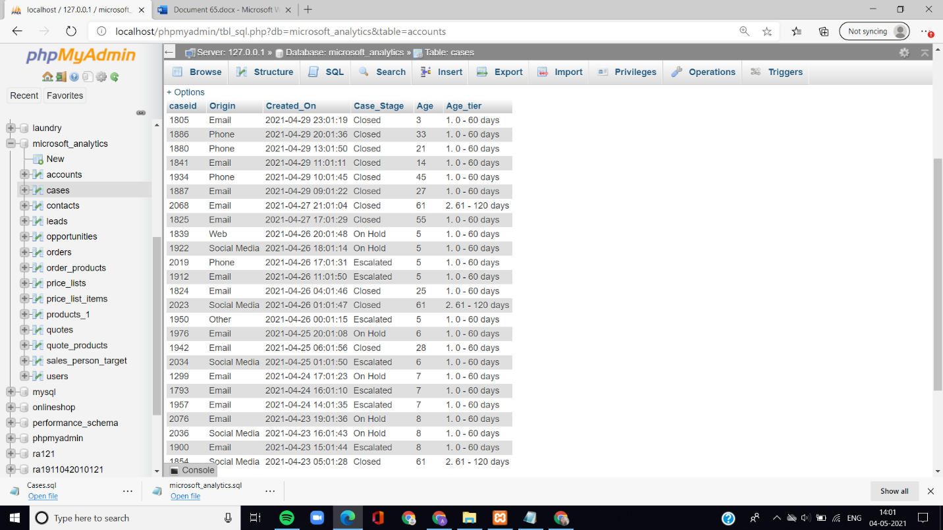

1. **Write a query to select all records for any total_amount less than $22.66K from orders table.**

**SQL>**

SELECT * FROM orders

WHERE Total_Amount> any(SELECT Total_Amount

FROM orders

WHERE Total_Amount < '$22.66K');

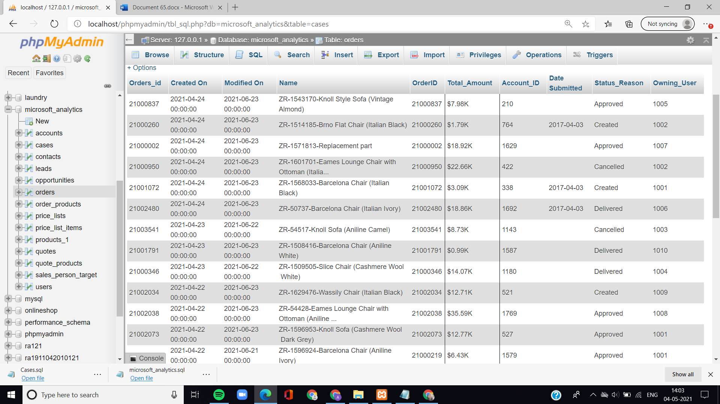

1. **Write a query to select all records for all current_cost less than INR 1,656.17 from products_1 table.**

**SQL>**

select * from products_1

where Current_Cost>

all(select Current_Cost

from products_1

where Current_Cost < 'INR 1,656.17');

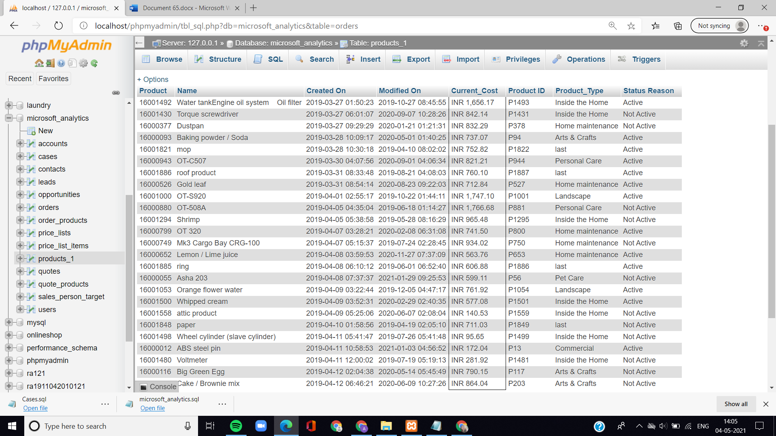

1. **Write a query Name, product, current cost, product type from products who has amount more than 500 from the table price list items.**

**SQL>**

* + select Name, Product, Current_Cost, Product_Type
  + FROM products_1 p
  + where Product_ID not in
  + (select Product
  + from price_list_items i
  + where p.product_id=i.product_id and i.amount> 500);

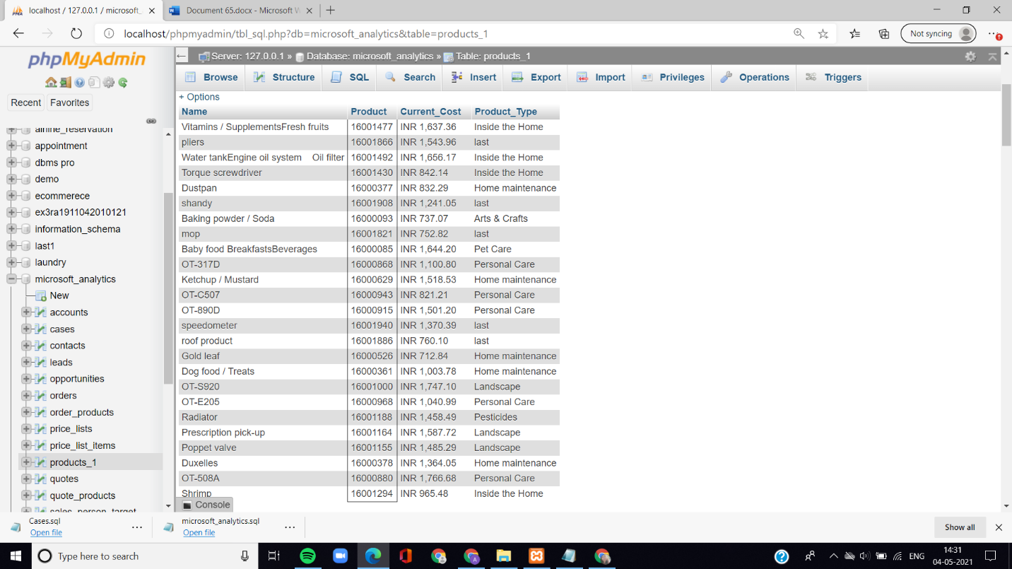

1. **Select order id name of the top most 5 having highest total amount.**

**SQL>**

select Orders_id, Name

from orders as O

where(select count(*)

from orders as p

where p.Total_Amount > o.Total_Amount) < 5;

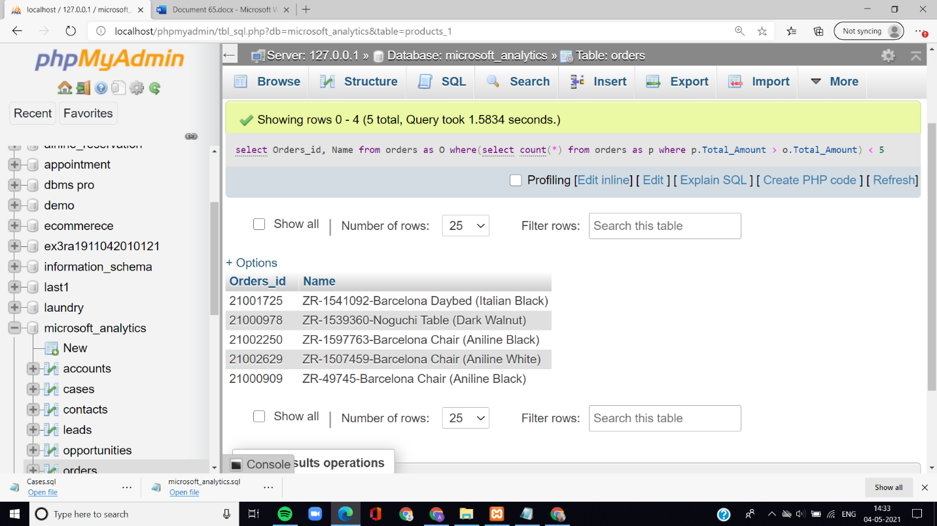

1. **Select name, product having status reason active and product type either personal care or home maintenance who have top 12 products.**

**SQL>**

SELECT P.Name, P.Product

FROM products_1 P

WHERE (Status_Reason ='Active' OR Product_Type='personal care' or Product_Type=' home maintence')

AND P.Product IN ( SELECT S.Product

FROM price_list_items S

JOIN price_lists L ON S.Price_List = L.Price_List

GROUP BY S.Product, L.Name

HAVING COUNT(*) < 12);

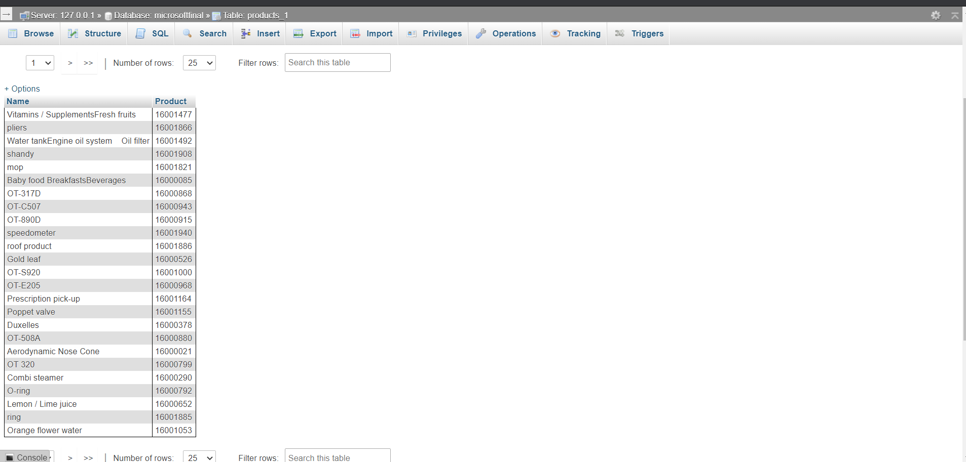

1. **Write a query to select name and price list having status reason = active, name wise having price list greater than avg price list.**

**SQL>**

SELECT Name, Price_List

FROM price_lists

WHERE Status_Reason='Active'

GROUP BY Name

HAVING AVG(Price_List)>

(SELECT AVG(Price_List)

FROM price_lists);

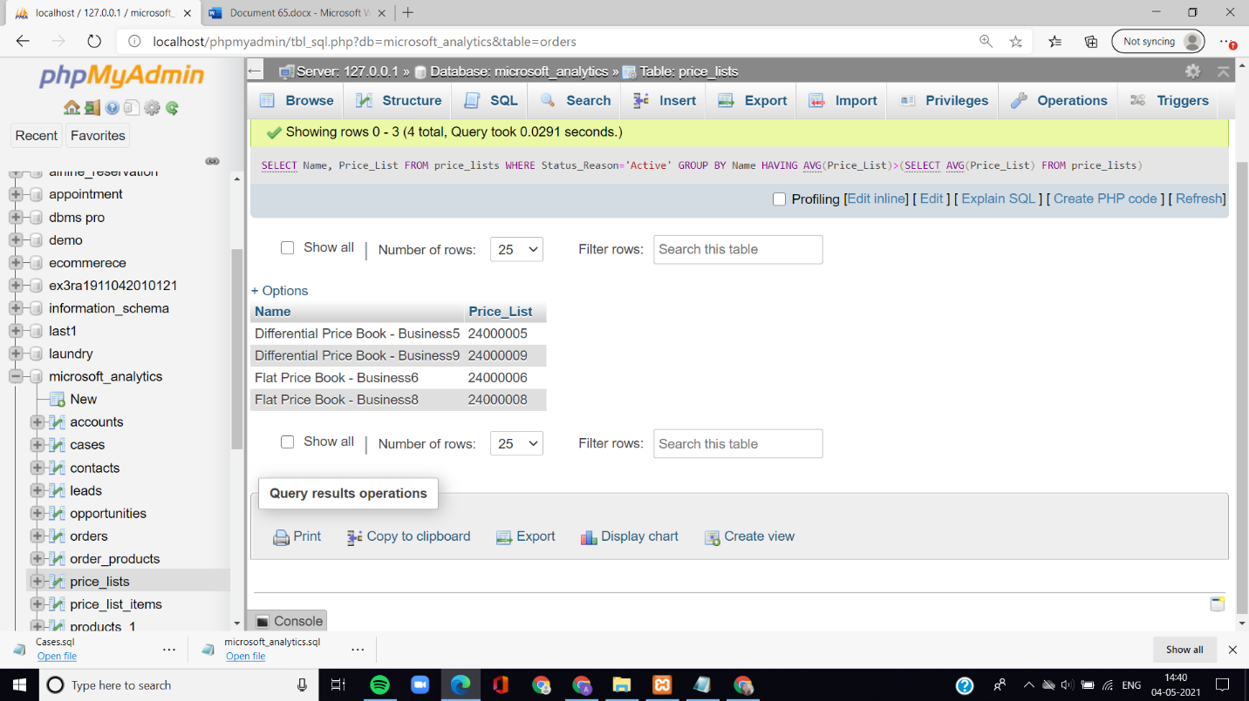

1. **Write a query to select price list, products from price list items and left join with name and created on from table product, join on product id.**

**SQL>**

SELECT price_list_items.Price_List,price_list_items.Product,products_1.Name,products_1.Created_On

FROM price_list_items

LEFT OUTER JOIN products_1

ON(price_list_items.Product_ID=products_1.Product_ID);

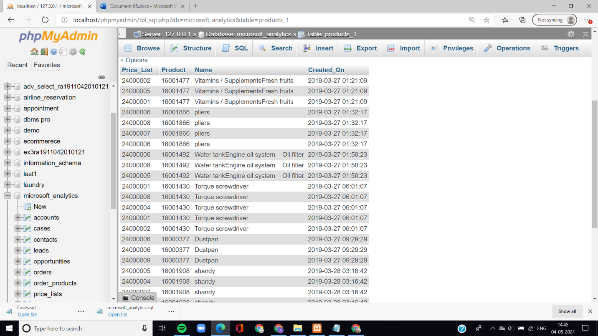

1. **Write a query to select opportunity, topic without having es in between and having total account amount more than 200.**

**SQL>**

SELECT Topic, Opportunity, SUM(Account_Amount)

FROM opportunities

WHERE Topic NOT LIKE '%es%'

GROUP BY Topic

HAVING SUM(Account_Amount)>200

ORDER BY SUM(Account_Amount);

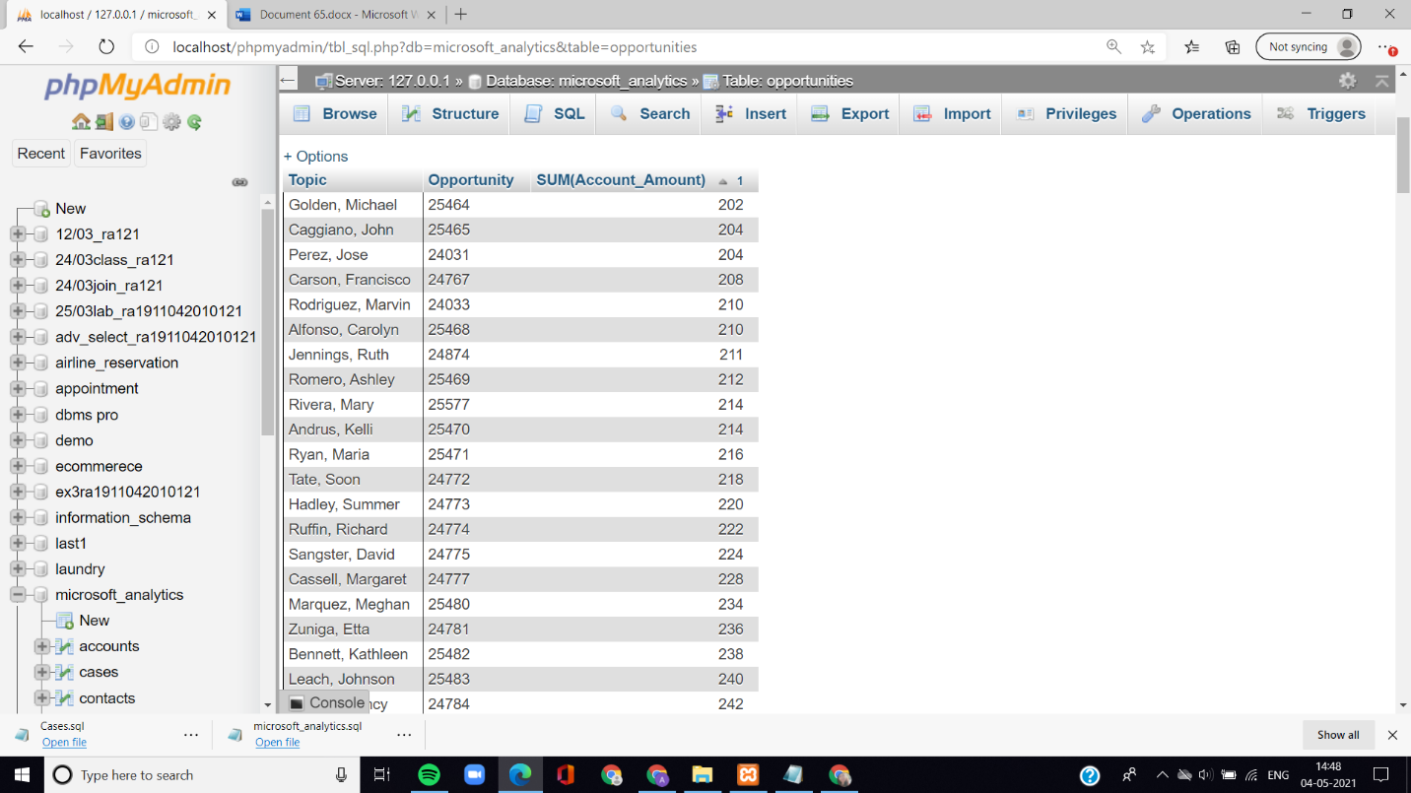

1. **Write query to select name where product id of product is equal to product id of price list and status reason is active.**

**SQL>**

SELECT Name

FROM products_1 p,price_list_items l

WHERE p.Product_ID=l.Product_ID

AND Status_Reason='Active';

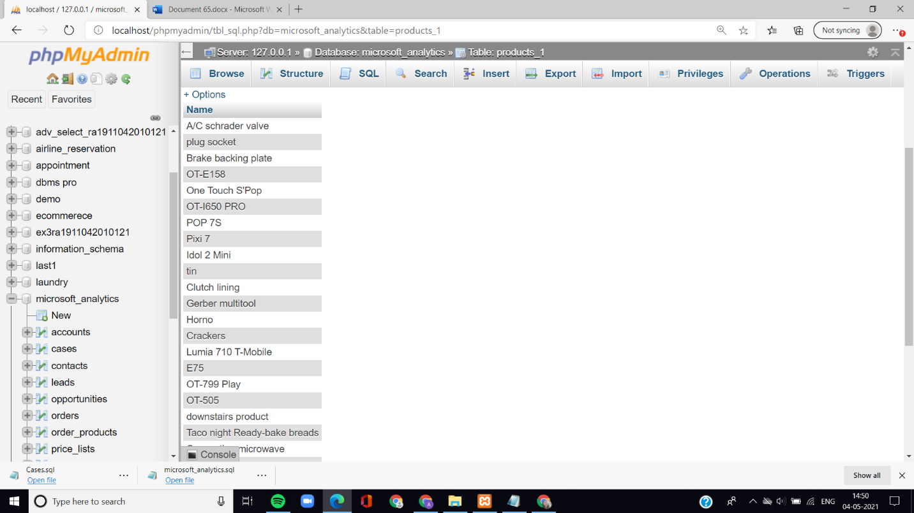

1. **Write a query to select lead, industry and avg of owning user by group in lead.**

**SQL>**

SELECT Lead, Industry, AVG(Owning_User)

FROM leads

GROUP BY Lead

ORDER BY Lead DESC;

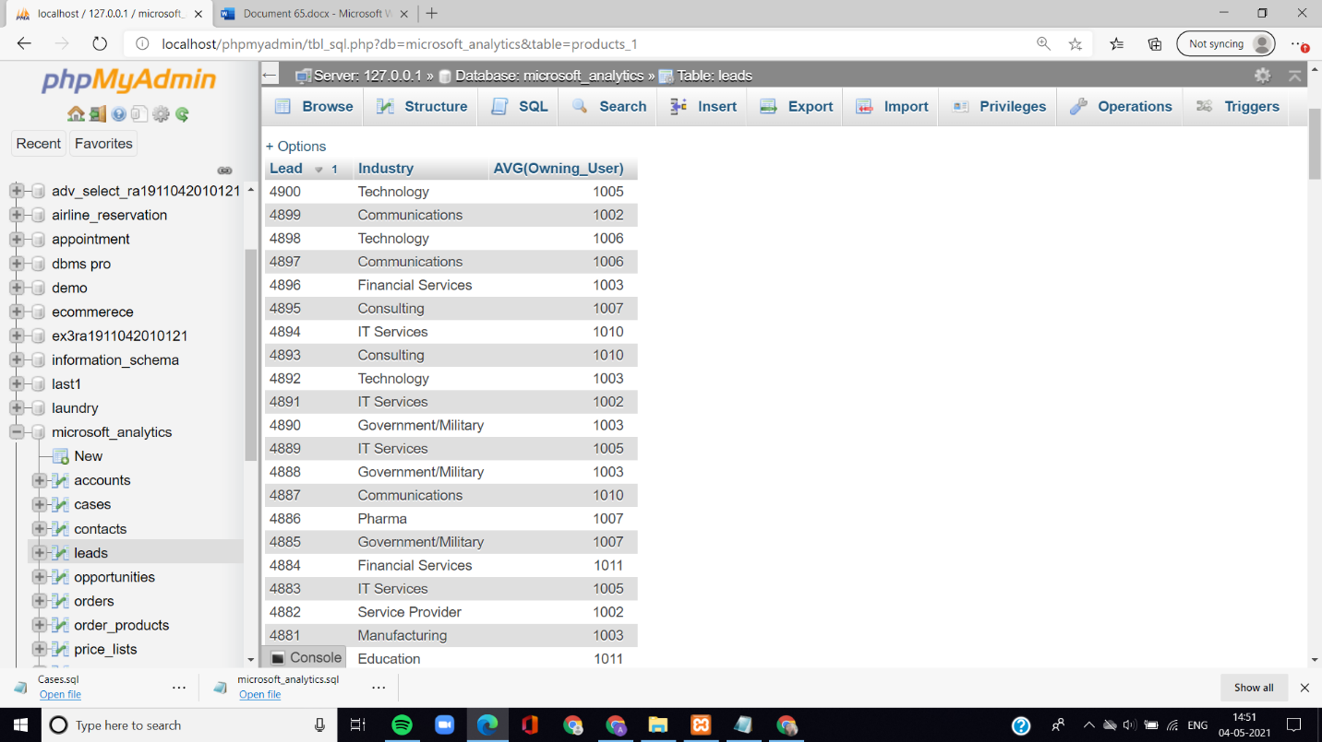

1. **Select caseid, origin and sum of age and group by case id.**

**SQL>**

SELECT caseid, origin, SUM(Age)

FROM cases

GROUP by caseid;

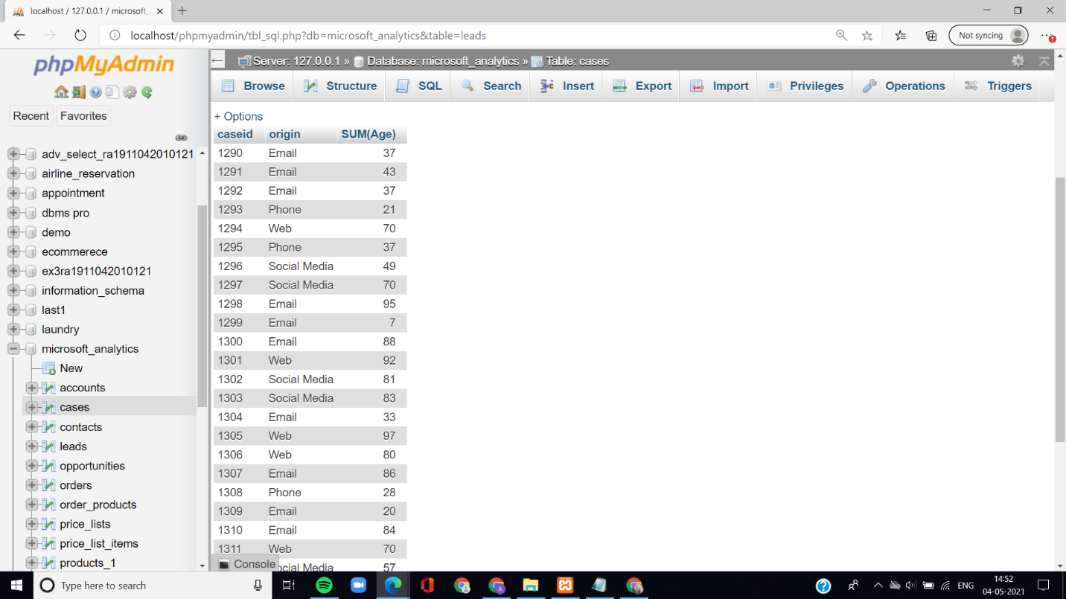

1. **Write a query to select topic probability and avg of opportunity with opportunity lead greater than 1500 in probability wise.**

**SQL>**

SELECT Topic, AVG(Opportunity), Probablity

FROM opportunities

WHERE Originating_Lead>1500

GROUP by Probablity;

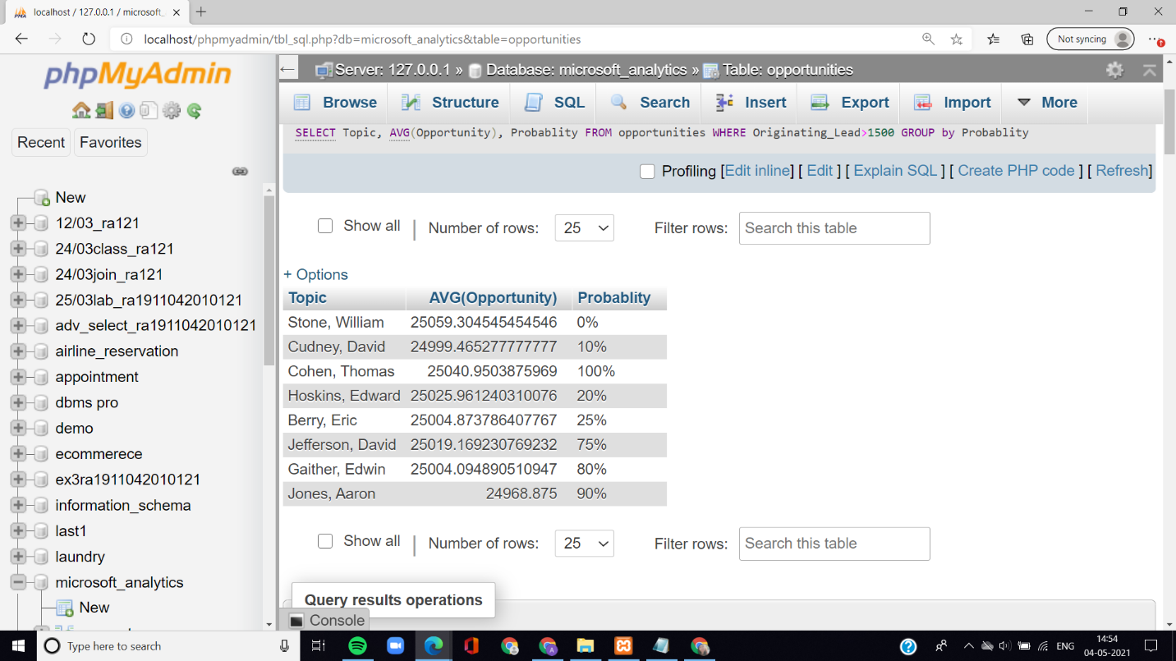

1. **Write a query to count the opportunities by account amount wise.**

**SQL>**

SELECT COUNT(Opportunity), Topic

FROM opportunities

GROUP BY Account_Amount;

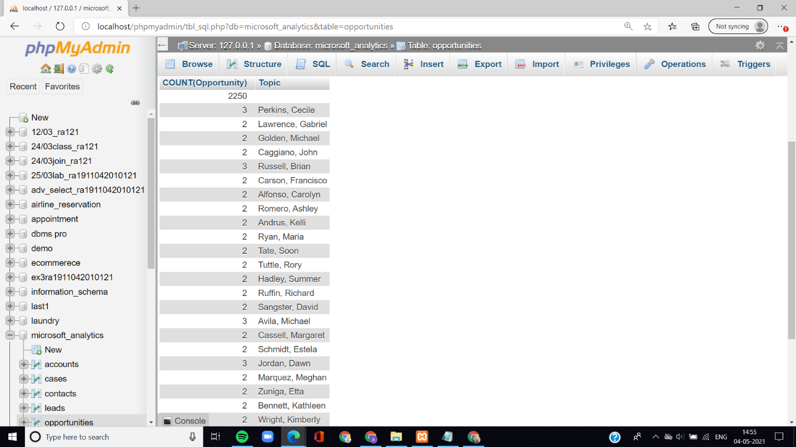

1. **Write a query to select all the records from accounts and contacts table**.

SQL>

SELECT accounts.Account,accounts.Account_Name,accounts.Industry,

Accounts.Owning_User,accounts.Website,accounts.Business_Type,

contacts.Contact,contacts.lastname,contacts.Created_On,contacts.Email,

Contacts.Owning_User,contacts.Parent_Account,contacts.Mobile,contacts.Lead_Source

FROM accounts,contacts;

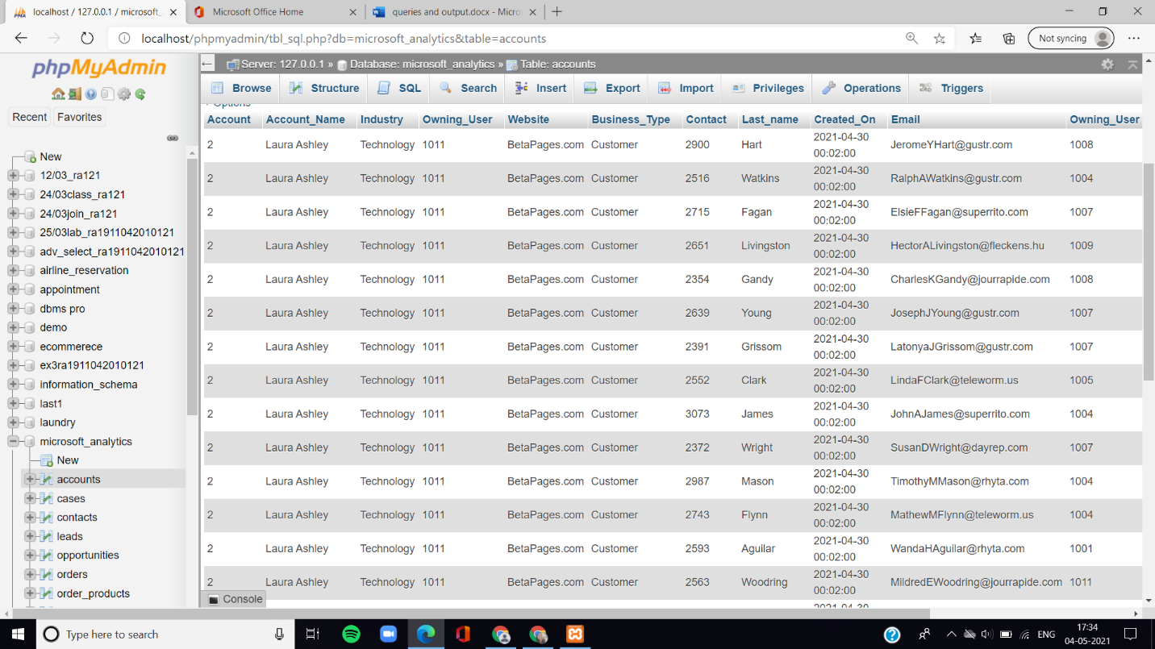

1. **Write a query to left JOIN table orders and order product on order id.**

**SQL>**

SELECT r.Orders_id, r.Name, t.Amount

FROM orders r LEFT OUTER JOIN order_products t

ON (r.Orders_id = t.Orders_id);

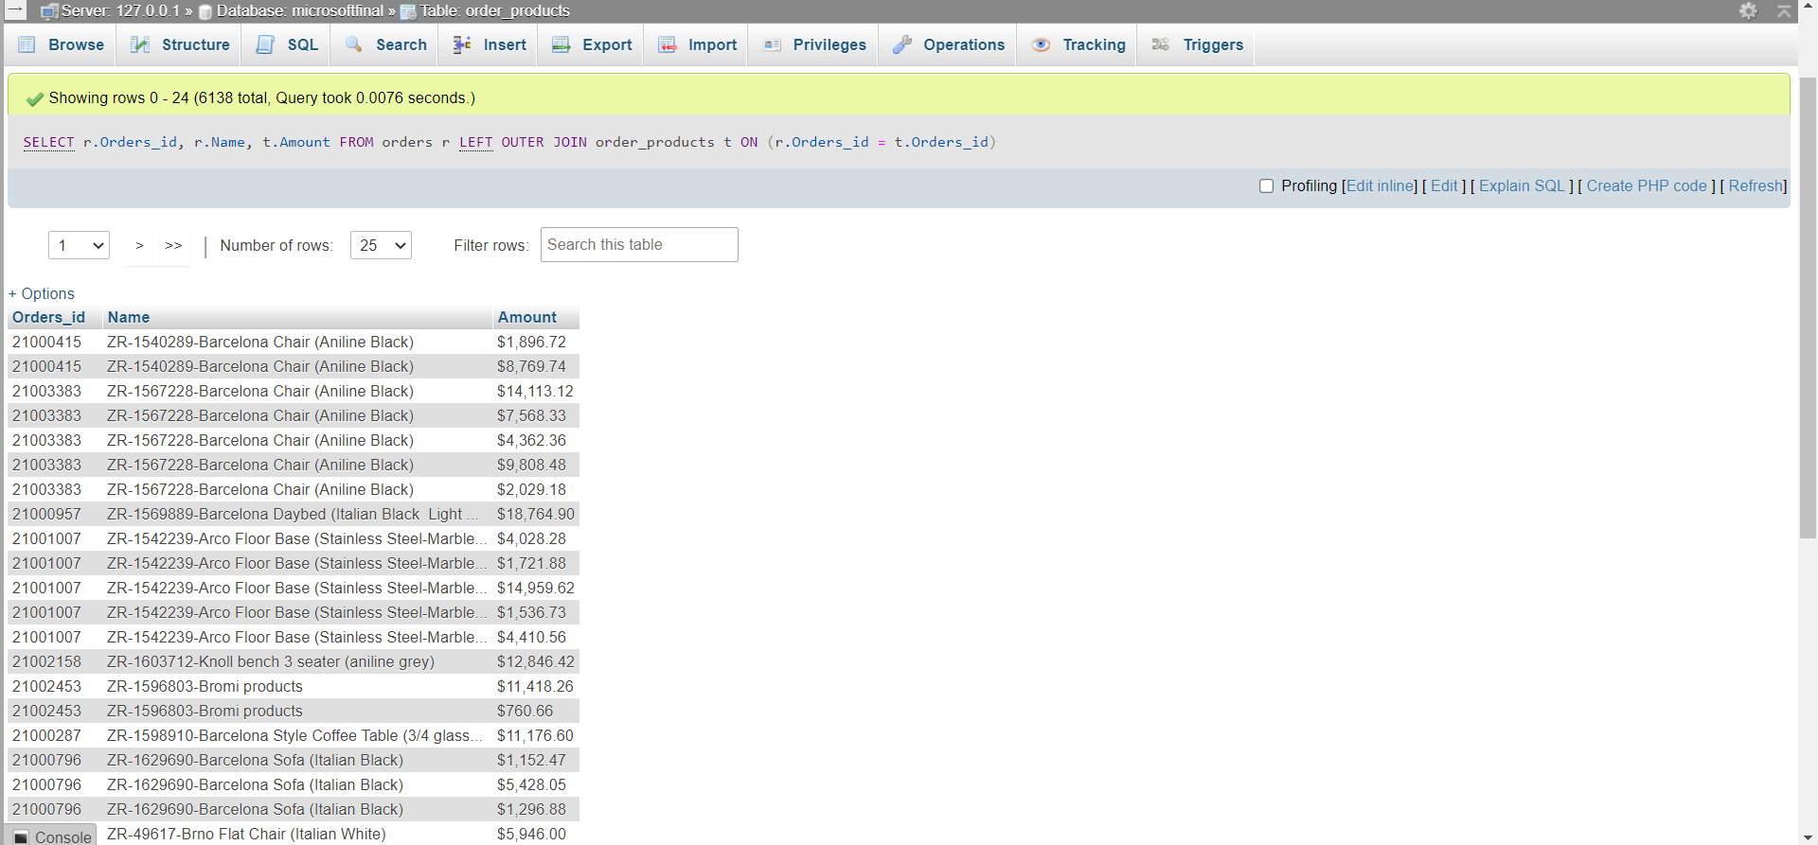

1. **Write a query to right join table orders and order product on order id.**

**SQL>**

SELECT r.Orders_id, r.Name, t.Amount

FROM orders r

RIGHT OUTER JOIN order_products t

ON (r.Orders_id = t.Orders_id);

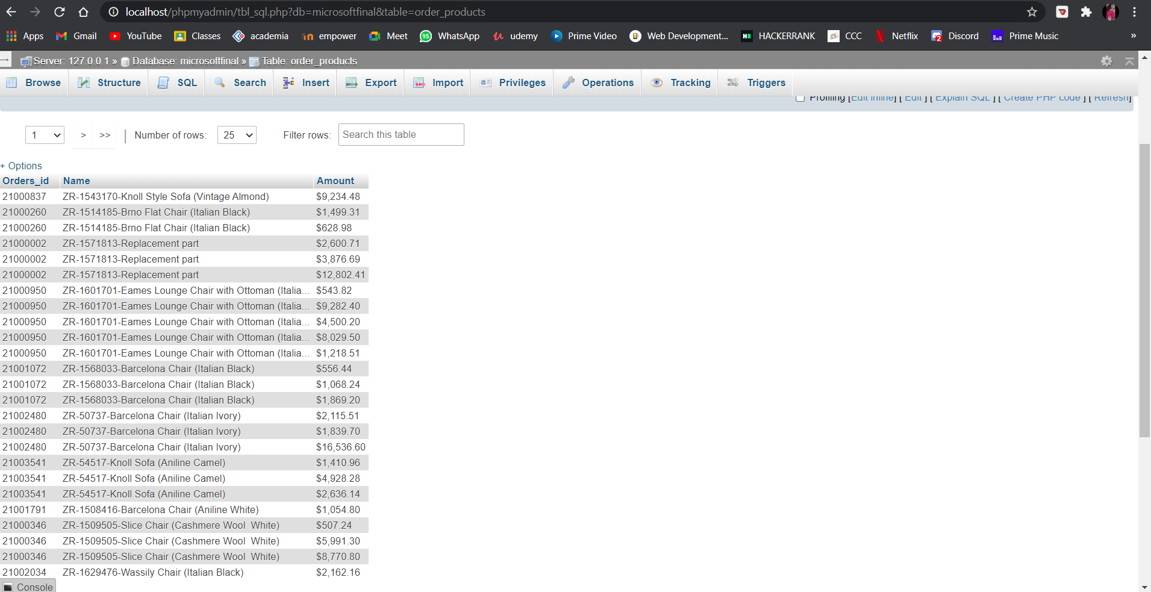

1. **Write a query to select price list product product id and amount where amount is less than 1000.**

**SQL>**

SELECT Price_List,Product, Product_ID, Amount

FROM price_list_items

WHERE amount < 1000;

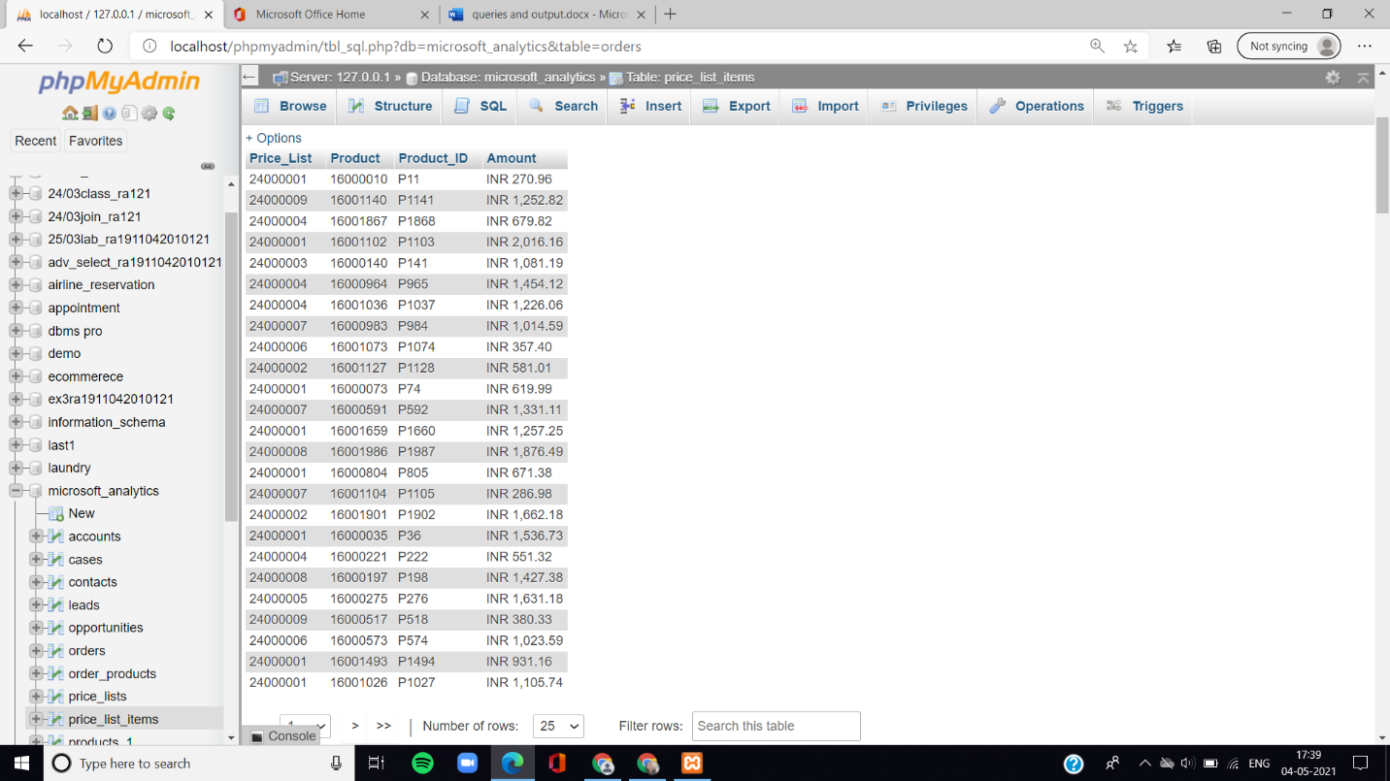

1. **Write a query to select order id, name, total amount and account id where total amount is equal to order id of 21003541.**

**SQL>**

select Orders_id, Name, Total_Amount, Account_ID

from orders

where Total_Amount =

(select Total_Amount

from orders

where Orders_id=21003541 );

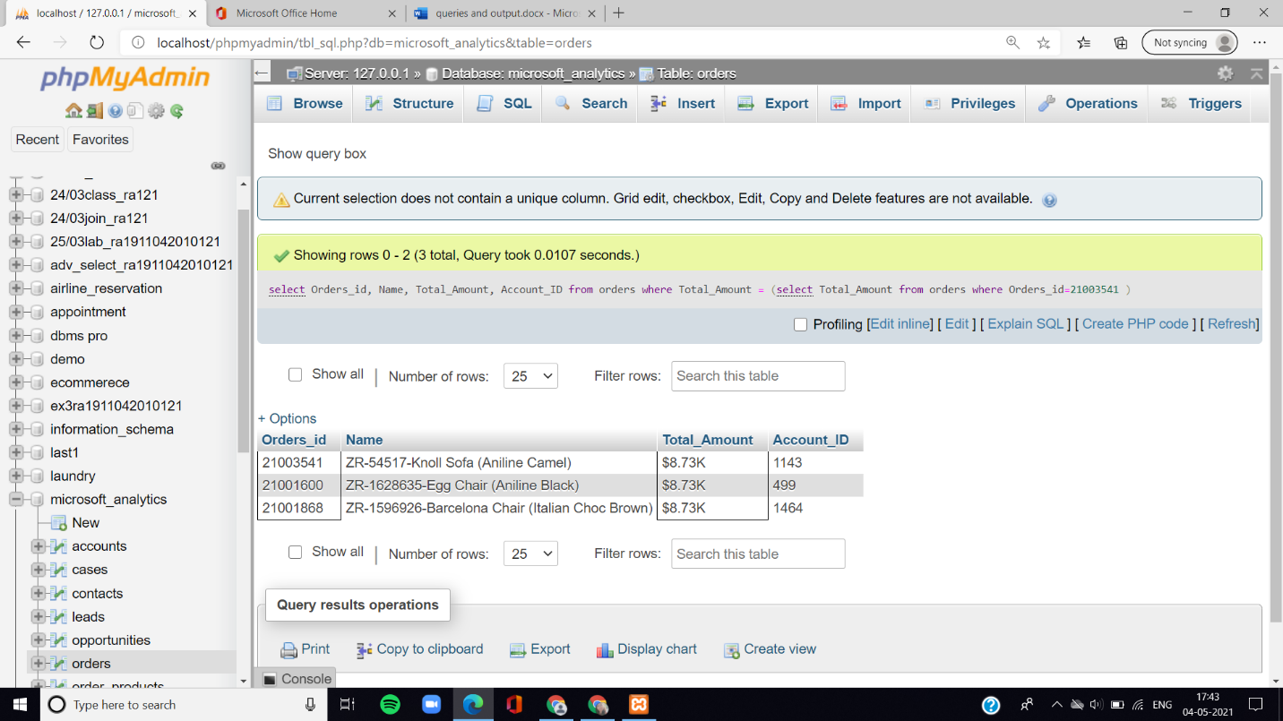

1. **Write a query to select all records where user is equal to 1010.**

**SQL>**

SELECT * FROM users WHERE User='1010';

